Key terms revision Y8

Djole - Music originated from Sierra Leone/West Africa
Ostinato – Repeated musical idea
Pulse – Musical Heartbeat
Instruments mainly used in Djole – Balafon, Dundun, Djembe, Agogo bell, Shekere
Master drummer - Leads an ensemble or group of musicians
Polyrhythm texture – Two or more rhythms played at the same time
Call and response – A musical question and answer
Percussion – An instrument that you can hit or scrape
Strings – An instrument that produce sound from vibrating strings when a performer strums, plucks, strikes or sounds the strings
Woodwind – An instrument that is played by blowing air into a mouthpiece with either one or two reeds and using the fingers to open and close holes to change the pitch
Brass – An instrument played by vibrating the lips against a cup-shaped mouthpiece and made out of brass.
Djole is a fast tempo piece, with a steady beat, loud dynamics, upbeat, energetic singing, catchy and rhythmically ostinato.
Major tonality – Happy mood (You cannot use this term to describe music made with only percussions)
Minor tonality – Sad mood (You cannot use this term to describe music made with only percussions)
Structure – The way your musical material is organised. E.g. Intro – Section A/Rhythm A – Call and response – Ending
Improvisation – Making new music on the spot
Solo - When a musician begins to improvise

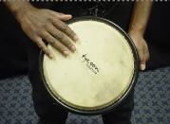
Tone sound – Played on the edge of the djembe
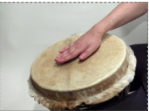
Bass sound – Played on the centre of the djembe
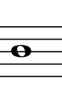
Semibreve – four beats count
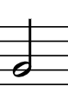
Minim – two beats count
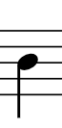
Crotchet– One beat count
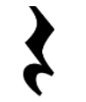
Crotchet rest – One beat rest count
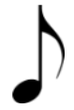
Quaver – Half a beat count

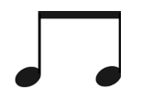
Pair of quavers – two beats count

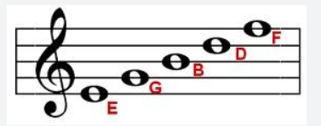
Notes on the lines – E, G, B, D, F
Every Green Bus Drives Fast

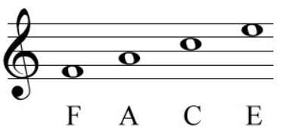
Notes on the spaces – F, A, C, E
Face in the spaces
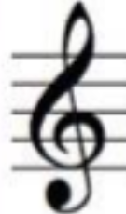
Treble clef
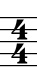
4/4 Time signature – 4 beats in a bar

